MANOR ROYAL BID MAINTENANCE TEAM ACTIVITY REPORT
Activity month | November 2020December 2020  January 21 |  | Baseline hours provided
Report date | 8/2/21 |  | Additional hours provided
Person | Christian Threader
Activities carried out ()
Road / area | Zone | Grass cutting | Litter picking | Weed control | Hedge cutting | Leaf clearance | Bin empty | Waste clearance | Pavement cleaning | Edging | Sign cleaning | Winter maintenance | Other
All areas | All |  | X4 |  | X1 |  | X12
Baird Close | 4
Betts Way | 1
Cobham Way | 5
County Oak Lane | 1 |  | +2
County Oak Way | 1 |  | +2
Crompton Way | 3 |  | +2
Faraday Road | 2
Fleming Way | Various
Gatwick Road | Various |  | +3 |  |  | +2
Hydehurst Lane | 2
James Watt Way | 5 |  | +3 |  |  |  |  | +2
Jenner Road | 2 |  | +1
Kelvin Lane | 2 |  | +2
Kelvin Way | 2 |  | +4 |  |  |  |  | +3
London Road | Various |  | +1
Manor Royal (road) | 2/3 |  | +3 |  |  | +5
Maxwell Way | 4
Metcalf Way | 1 |  | +5 |  |  | +2 |  | +2
Napier Way | 3 |  | +2 |  |  | +2 |  | +1
Newton Road | 2
Priestley Way | 5
Royce Road | 5 |  | +1
Rutherford Way | 5 |  | +2
Tinsley Lane | 4 |  | +2 |  |  | +1 |  |  |  |  | +1
Tinsley Lane North | 5 |  | +1 |  |  | +1
Wheatstone Close | 5
Whittle Way | 5
Whitworth Road | 5
Woolborough Lane | 3 |  |  |  |  | +2
Gateway 1 (Manor Royal) | - |  | +2
Gateway 2 (near Thales) | - |  | +2
Gateway 3 (near Astral) | -
Gateway 4 (James Watt) | -
The Terrace | - |  | +4 |  |  | +4
Crawters Brook | -
Gatwick Road Parade | - |  | +7 |  |  |  |  |  |  |  |  | +2
Woolborough Subway | - |  |  |  |  | +3
Green Lane Subway | - |  | +1 |  |  | +3

Main actions provided
Since our last report in October we have been addressing various winter maintenance issues.
November – we completed a final grass cut of the year, in the early part of November, before spending a majority of our time leaf clearing throughout Manor Royal. This involved support from the tractor team with the vacuum attachment. Litter picking, fly tipping and tree branch debris removal, was also carried out across Manor Royal.
December – leaf clearing took up a majority of our time, as we continued to concentrate on clearing high footfall areas. We also carried out street cleaning on some of the worse signs, such as Tinsley lane south, cut back unwanted tree rooted epicormics and cleared detritus throughout various areas of Manor Royal. A day was spent replacing banners with the support of the cherry picker JCB and the remainder of our resource time was litter picking and removing fly tipping.
January- unfortunately we had sickness issues through Covid, however additional support was given to the Manor Royal Maintenance team from one of our Neighbourhood teams who helped with deep cleaning of litter picking in various hotspot areas of Manor Royal. We also gritted some areas, such as bus stops and main footpaths and footbridges. Covid restrictions have impacted the detail of this month’s report, as the maintenance team have had issues with sharing IT and office space.

Comments and observations
Our main observations at this time of year has been to keep on top of fly tipping, litter, leaf fall and gritting. We are aware that not all the banners have been attended to, however we are in communication with the tractor team and we hope to complete the remaining fixing or replacing of banners in February.

Suggestions for future actions, improvements or additional activities planned
Our main plans for the coming weeks are finishing the final banners, continue with street sign cleaning, grit high footfall areas and for Februarys report to include new season grass cutting plans and to provide additional photos to go with the February report.

Photographic Impact Evidence (a selection of photos of work undertaken to demonstrate impact)
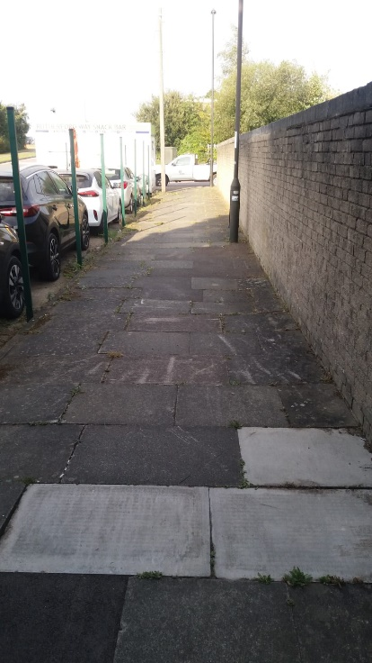
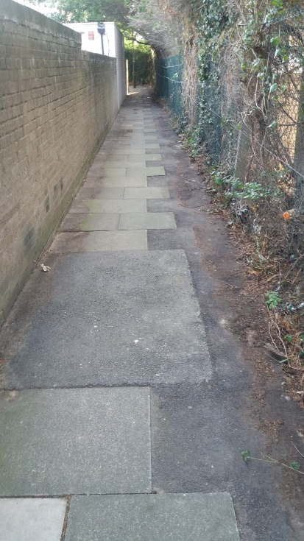
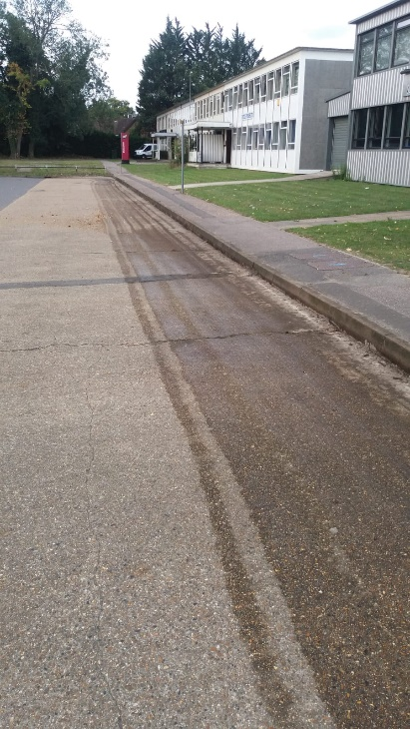
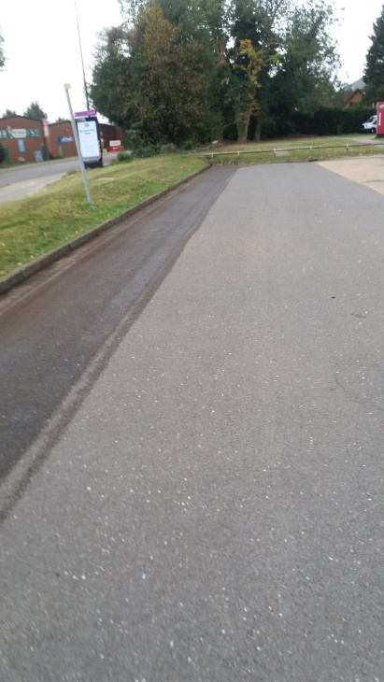
Gatwick Road Parade Street Cleaning

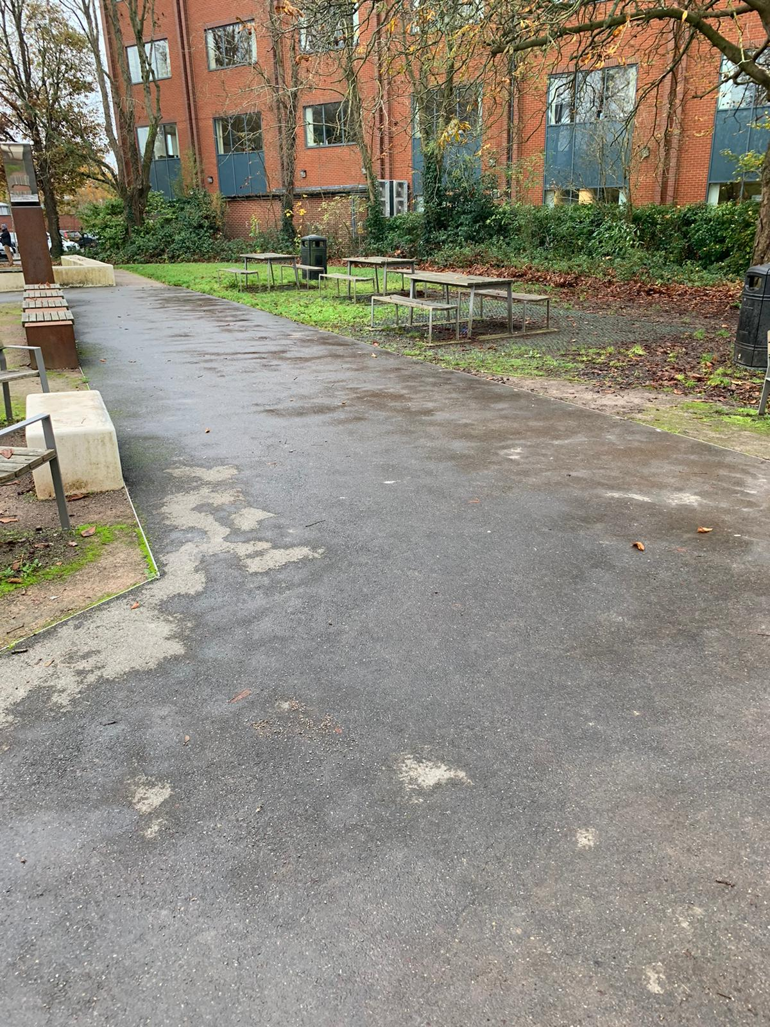
Terrace Leaf Clearance (Before and After)
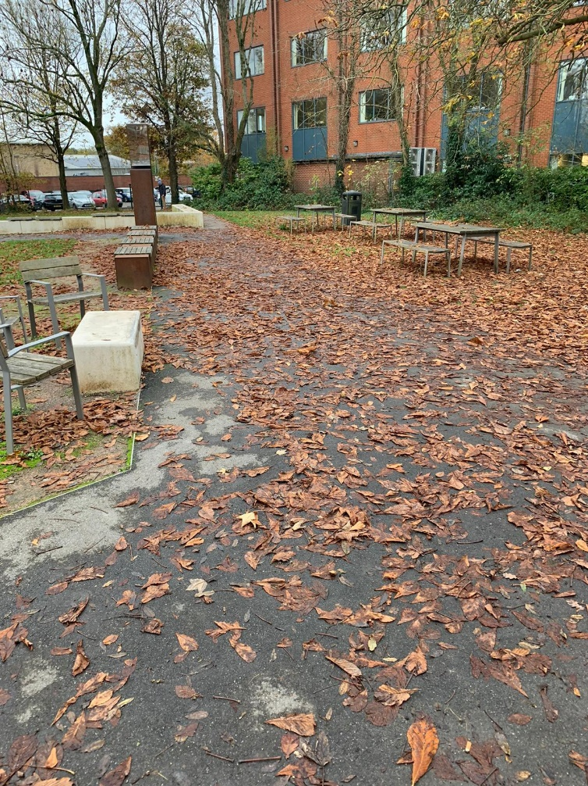

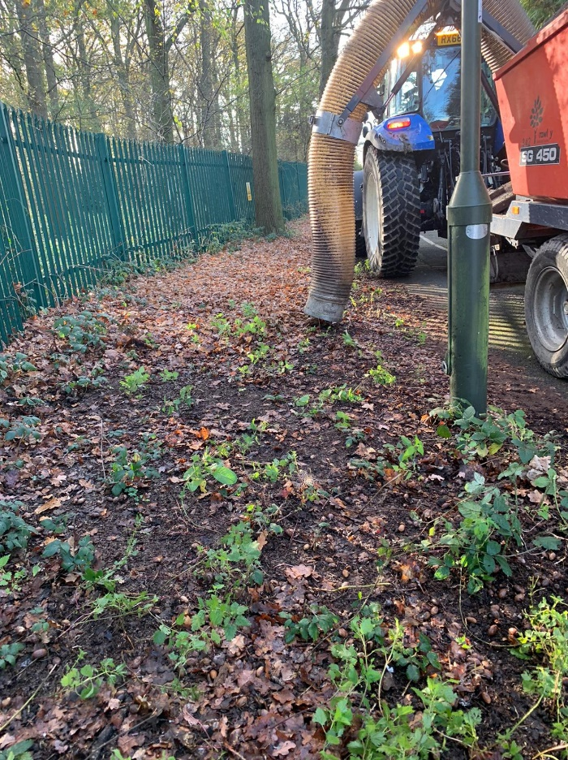
Leaf clearance using the Trilo machine (Magpie Walk)
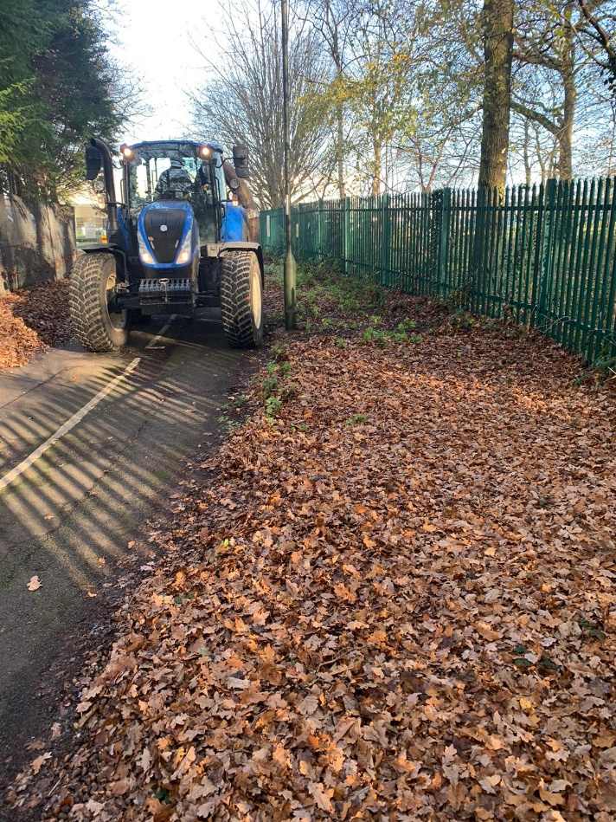

Leaf clearance at Woolborough Lane and fly tipping at Gatwick Road Parade
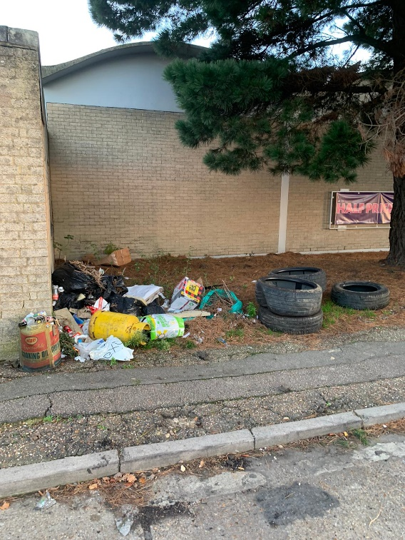
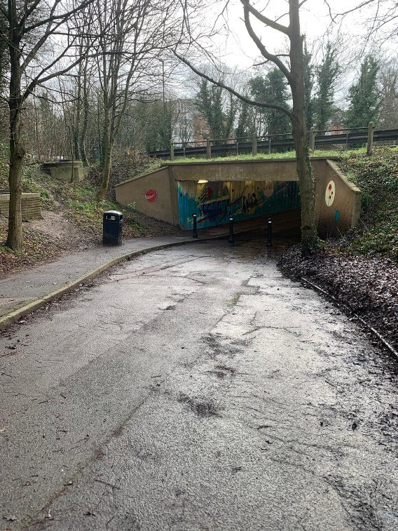
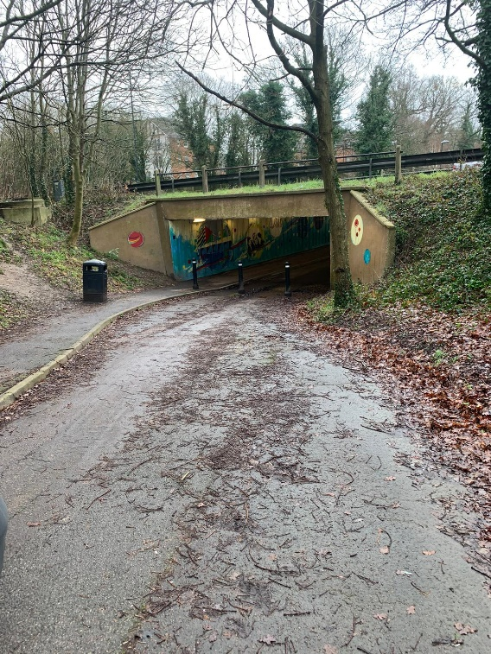

Details of CORE and ENHANCED Service levels (contract extract)

Current Baseline Service | Proposed | Enhanced element (* estimated)
Monthly litter pick (12 pa) | Weekly litter pick (52 pa) | X40 litter picks  + identify hotspots and trial extra bins
Weekly litter bin empty (52 pa) | Weekly litter bin empty (52 pa) | -
Monthly road sweep (12 pa) | Monthly road sweep (12 pa) | -
- | Remove fallen leaves and detritus from footpaths and common areas (4 pa) | X4 leaf and detritus removals
- | Washing and cleaning street furniture and signs to include street name signs, gateway / entrance signs, wayfaring signs and highways signs (2pa) | X2 washes
- | Deep cleaning/jet washing common areas, bus stops and paved areas (as required) | As required
Grass cutting (5 pa) | Grass cutting (12 pa) | * X7 grass cuts – (weather/ground conditions dependant)
Bunded/bank grass cutting (4 pa) | Bunded/bank grass cutting (10 pa) | X6 bunded/bank cuts
Hedgecutting (1-2 pa) | As required (2-3 pa) | * 1-2 Hedge cuts
Shrub maintenance (2-3 pa) | As required (4-5 pa) | * 1-2 shrub maintenance
Weedspraying (2 pa) funded by WSCC | Weed spraying (4 pa)  Removal of dead standing weeds (4pa)  Weed ripper as required | X2 weed sprays  X4 dead weed removals  Weed ripper as required  On footpaths and common areas
See note 1 | Box mow and maintain Gateway 3 Roundabout (10 pa) | X10 Box mow and maintain Gateway 3 Roundabout
- | Crawters Brook, The Terrace enhanced Maintenance (as Annex C) | Crawters Brook, The Terrace enhanced Maintenance (as Annex C)
- | Weekly inspection and rectification/reporting of faults found. | X52 inspections - reports/rectification of faults found
- | Reactive/response service through a single point of contact as required | Reactive/response service as required
- | Provide monthly information…  - feedback on what has been done and what is planned  - Available performance data - quantities such as volumes, lengths, waste weights etc (tba)  - photographic evidence of before and after improvements,  - suggestions for further/future enhancements  - Attend meetings as required | X12 reports (monthly)
Notes: (1) There is a requirement for Gateway 3 and Crawter’s Brook People’s Park to be maintained to a basic level as described in the Annexes.

